ASC Annual Conference Proceedings Style and Formatting Guide

First Last ¹, First Last ², First Last¹, and First Last³
¹University Name 1, ²University Name 2, ³University Name 3

The abstract will be formatted within a single table, one aligned left 10 pt. return between the author table and the abstract table. The table size is established by setting the table’s width to 100% and alignment to “centered.” The text within the table is justified with no indents. Borders and shading must be set to “none.” The font is 10 pt., Times New Roman, and is limited to one paragraph under 200 words. No hard returns are to be included within the abstract. The abstract should concisely summarize the whole paper, including the purpose, methodology, key findings, and conclusions. It should be written in a clear and straightforward manner, avoiding jargon and technical terms that might not be familiar to all readers. The keywords are to be included within the abstract table one hard return below the abstract. Provide no more than five key reference words. Keywords should be chosen carefully to ensure they accurately reflect the main topics of the research and will help others find the paper in searches.

Keywords: Formatting, Style, Guide, Proceedings, EasyChair

Introduction

The styles and formatting illustrated in this guide are designed to conform to the requirements for publishing in the EasyChair system. In addition to clarifying style and formatting, this Word document is intended to provide authors with a template for writing their manuscripts.

The Associated Schools of Construction (ASC) allows a maximum of five (5) authors per submitted paper. No changes in authorship may be made after initial submission, except for spelling or other similar corrections. Authors may not be added after a paper has been submitted for consideration. Additionally, the initial paper submission is to be fully blinded, meaning free of any identifying information about the authors or their university of company affiliation.

Manuscript Specifications

The paper size will be – letter - 8½ in. x 11 in. Page orientation is to be portrait. All text throughout the document (other than the paper title) should be in Times New Roman, 10pt font. “Layout - section start” is set to “new page,” and “vertical alignment” is to be “top.” Top and Bottom margins are to be set at 1.48 inch (1.48"). Left and Right margins are set to 1.40 inch (1.40”). The gutter is set at zero inches (0"), and the position is set to “left” (see Figure 1). Each paragraph is single-spaced, aligned left only, with no indents. There is only one (1) hard return between paragraphs. Manuscripts shall be no more than 10 pages, including references, appendices, etc. Longer manuscripts will NOT be accepted.

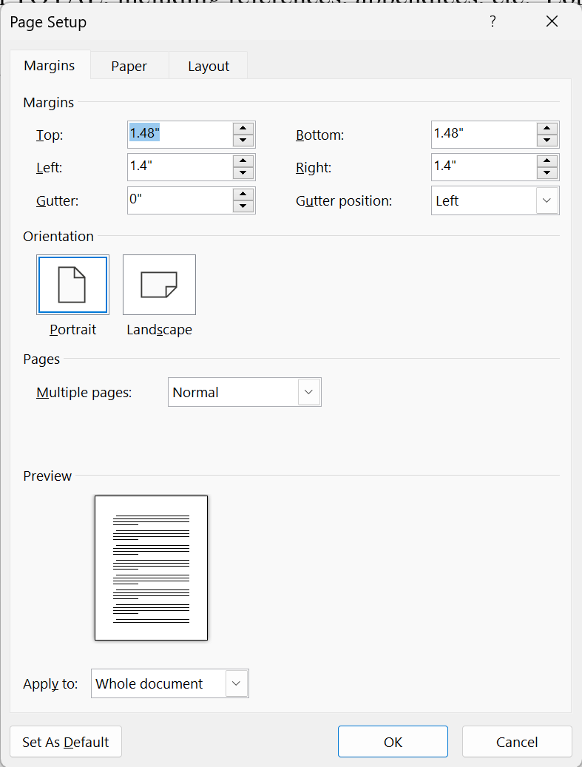
Figure 1. Page setup details

Body of Manuscript

Title

Title font size will be 16 pt., Times New Roman, bold, centered, and upper and lower case (Title Case). The title summarizes the main idea of the manuscript, and it is short and descriptive of the contents. No hard returns are to be included in the title. The title should reflect the full work being reported and be no longer than 20 words.

To set the location of the title, place the cursor at the beginning of the title line, select Format -> Paragraph in the Microsoft Word menu, and set the spacing before the paragraph to 94pt and after to 0pt. The empty space above the title is reserved for a page header containing the EasyChair logos and the volume information. This header will be added to the article when you submit it to EasyChair.

Author Information

Author information will be formatted into two rows directly after the title. The first row will include a listing of all authors (maximum of five) in order of contribution to the research and writing of the paper. Each name will include a numeral, formatted to superscript. The second row will contain the name of the university or company affiliations of the authors. The generic author information shown in this template should be used for the initial blinded paper submission.

1st Level Headings

Font size is 10 pt., Times New Roman, and bold. Headings are centered, upper and lower case (Title Case). One (1) hard return before the heading and one (1) hard return after the heading.

2nd Level Headings

The font size is 10 pt., and it is Times New Roman. Headings are centered, italicized, uppercase and lowercase heading, 1 line space before, and 1 line space after.

3rd Level Headings

The font size is 10 pt., and it is Times New Roman. Headings are flush left, italicized, uppercase and lowercase side heading, 1 line space before, and 1 line space after.

4th level headings. The font size is 10 pt., Times New Roman, and is flush left, italicized, lowercase paragraph heading ending with a period (.), 1 line space before, 3-character spaces after; paragraph begins the same line.

Citations

Citations, both in-text and full references, are to be per the American Psychological Association (APA) seventh edition. All citations must refer to sources listed in the references, and all sources listed must be cited from within the text. Refer to the examples below for proper listing of sources. If several publications are cited by the same author and from the same year, a, b, c, etc., should be put after the year of publication.

Examples:
Paraphrasing:
. . . As written (Jones & Moss, 1997). Or . . . As written (Jones & Moss, 1997) in the. . .

Directly quoting:
". . . As written" (Jones & Moss, 1997, p.17). Or . . . "as written" (Jones & Moss, 1997, p.17) in the . . .

Citing figures and tables:
. . . As written (see Figure 5).
. . . As written (see Table 5) in the . . .

Tables

Textual information is presented in column and row format. All tables must be created using the table function within the same word-processing system as the manuscript. No table may be included as an image file or inserted as a reference to another file document. The table size is established by setting the table's width to 100%" and alignment to "centered". All table elements (including titles) use Times New Roman, 10pt font. The table title appears as a single row at the top of the table (note punctuation, capitalization, and formatting displayed in the example). Borders and shading must be set to "none” except the title cell, header cells, and the last cell, which should have a bottom cell boundary of 1/2 pt. line. Column headings can be bold. Information within the table is to be formatted in Times New Roman 10pt font. There should be a hard return before and after the table. Tables with more than 40 lines in total will be included as an appendix.

Table 1. Example of table format
SLO | Description of SLO
1 | Create written communications appropriate to the construction discipline
2 | Create oral presentations appropriate to the construction discipline.
3 | Create a construction project safety plan.
4 | Create construction project cost estimates.
17 | Understand the basic principles of mechanical, electrical, and plumbing systems.

Figures

Figures include non-text entries such as graphs, illustrations, photos, and artwork (tables are not figures). Figures should be drawn using a suitable drawing package and embedded within the manuscript document. Only .gif and .jpg file formats are considered acceptable. Submitted images should adhere to the resolution setting of 300 dpi. A two (2) celled table contains the figures (center justified) and figure title (center justified). Figures will not have borders drawn around them and should be limited to two-thirds (⅔) of a page. The table size is established by setting the table's width to 100%" and alignment to "centered". Figure titles use Times New Roman, 10pt font, and appear in the bottom cell of the figure table (note punctuation, capitalization, and formatting displayed by the example). Do not include the figure title in the figure itself.

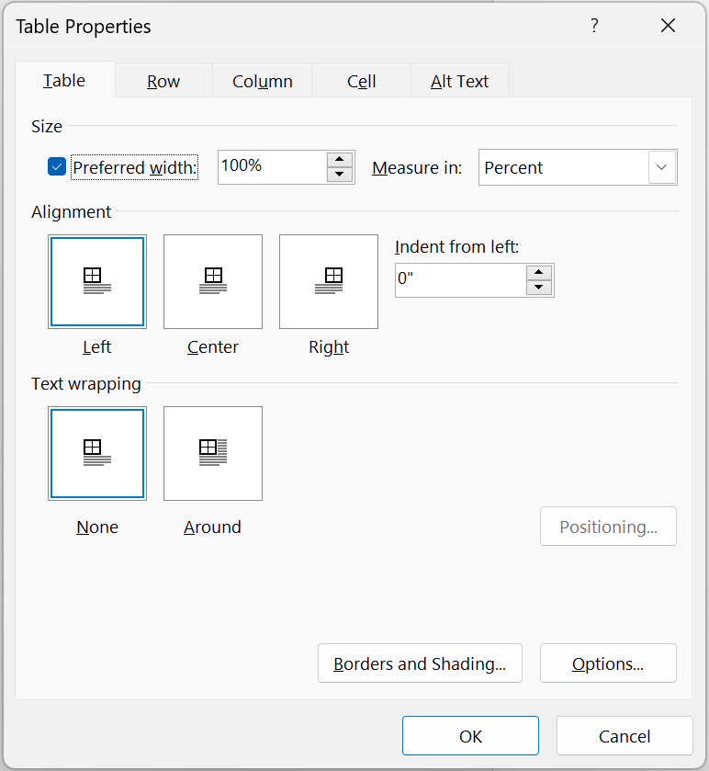
Figure 2. Example of table properties for figure setup

Bullets and Numbering

Items listed should be syntactically and conceptually parallel to the other items in the list and should be limited to itemized conclusions or steps in a procedure. Only minimal round bullets or Arabic numerals are to be used. The list is one space below the previous paragraph and indented 0.25" and is followed by one left justified space. Each of the separate items in the series is followed by a comma or period. Do not force or hard text your own bullets or numbering using tabs or indents. Use auto formatted only. You may format them to your specific needs. Below is an example of options.

- You may use round bullets.
- You could use numerals.
- In either case, the items are indented 0.25" and are followed by one left justified space.

Do Not Include

The following items should not be included in manuscripts.

- Use of any preformatted text style (e.g., Heading 1, Body Text), section or page breaks, headers, or footers.
- Use of tabs to indent text anywhere within the document.
- Use footnotes or comments within the manuscript.
- Use “he/she,” “he or she,” or like wordings. Language should remain non-gender specific unless germane to the content.
- Page numbers.

References & Appendices

Alphabetical listing of sources that were used in the research and preparation of the paper. Manuscripts should conform to the APA Publication Manual, 7th Edition. Arrange entries in alphabetical order by the surname of the first author. The font size is 10 pt., and it is Times New Roman. Alphabetize corporate authors, such as associations or government agencies, by the first significant word of the name. Full official names should be used. If there is no author, the title moves to the title position, and the first significant word of the title alphabetizes the entry. One hard return, aligned left, will provide a space between all entries. Single-space each entry. All references cited in the text should be listed in full at the end of the paper.

Appendices are labeled A, B, and C (when there is more than one) and are placed in the order they are first referenced in the text. Please limit the number of pages. Information within the appendix must be formatted in font size 10 pt., Times New Roman.

