ASC Proceedings Style and Formatting Guide for Publication in EasyChair

Tom Leathem, Ph.D. and Wes Collins, Ph.D.  Auburn University  Auburn, Alabama | Anthony Perrenoud, Ph.D.  University of Oklahoma  Norman, OK
Blake Wentz, P.E.
Milwaukee School of Engineering
Milwaukee, WI

The abstract will be formatted within a single table, one aligned left 10 pt. return between the author table and the abstract table. The table size is established by setting the table's width to 100%" and alignment to "centered". The text within the table is justified left and right with no indents. Borders and shading must be set to "none." Font is 10 pt., Times New Roman, and is limited to one paragraph under 200 words. No hard returns are to be included within the abstract. The key words are to be included within the abstract table one hard return below the abstract. Provide no more than five key reference words. Bold only the text “Key Words”.

Key Words: Formatting, Style, Guide, Proceedings, EasyChair

Introduction

The styles and formatting illustrated in this guide are designed to conform to requirements for publishing in the EasyChair system, as well as have similar features to the ASC International Journal of Construction Education and Research. In addition to providing clarification about style and formatting, this word document is intended to provide authors a template for writing their manuscripts.

ASC allows a maximum of five (5) authors per submitted paper. No changes in authorship may be made after initial submission, except for spelling or other similar corrections. Authors may not be added after a paper has been submitted for consideration.

Manuscript Specifications

Paper size will be – letter - 8½ in. x 11 in. Page orientation is to be portrait. Unless otherwise noted, all text throughout the document should be Times New Roman, 10pt font. “Layout - section start” is set to “new page” and “vertical alignment” is to be “top”. Top and Bottom margins are to be set at 1.48 inch (1.48"). Left and Right margins set to 1.40 inch (1.40”). The gutter is set at zero inches (0") and position set to “left” (see figure 1). Each paragraph is single spaced, aligned left only, no indents. There is only one (1) hard return between paragraphs. Manuscripts shall not exceed 9-pages in length TOTAL, including references, appendices, etc. Longer manuscripts will NOT be accepted.

Figure 1. Page setup details

Do Not Include

The following items should not be included in manuscripts.

- Use of any preformatted text style. (i.e., Heading 1, Body Text)
- Use of tabs to indent text anywhere within the document. Do not use tabs to build tables. Use the table options of your text editor. You may use the increase indent or decrease indent button of your text editor
- Include works for further reading
- Use footnotes or comments within manuscript. (Citations are to be placed within the text and not at the bottom of the page.)
- Headers or footers placed in the document
- Include the word "Abstract" above the abstract paragraph
- Use “he/she”, “he or she” or like wordings. Language should remain non-gender specific unless germane to the content.
- Include page numbers in the document
- Include section or page breaks in the document
- Include date and time stamps, auto text, fields, captions, cross-references, or indexes in the document.

Body of Manuscript

Title

Title font size will be 18 pt., Times New Roman, bold, centered, and upper and lower case (Title Case). The title summarizes the main idea of the manuscript, short, and descriptive of the contents. No hard returns are to be within the title.

To set the location of the title, place the cursor at the beginning of the title line, select Format -> Paragraph in the Microsoft Word menu and set the spacing before the paragraph to 94pt and after to 0pt. The empty space above the title is reserved for a page header containing the EasyChair logos and the volume information. This header will be added to the article when you submit it to EasyChair.

Authors Table

Author information will be formatted within a single table, one aligned left 10 pt. hard return between the title and the author table. The table size is established by setting the table's width to 100%" and alignment to "centered". Borders and shading must be set to "none." Authors from the same institution are placed within the same cell, joined by the word “and.” (see figures 2a & 2b). The number of cells will depend upon the number of authors from differing institutions. No table will be over two cells wide (see figure 3), but may contain multiple rows (see figure 4). The first line is (bold) and contains the author’s first name, middle initial, and surname followed by their degree i.e., Ph.D., MSCS and certifications and licenses i.e., CPC, PE. The second line (not bold) is their institutional affiliation. The third line (not bold) is their institution’s city and state.

Papers are BLIND REVIEWED so please do not include authors name or any identifying associations in the papers content (example: University of **** at ****) until the paper has been accepted (or accepted with modifications) for publication and presentation in the conference. In the initial submission, the authors table should be included without identifying author information.

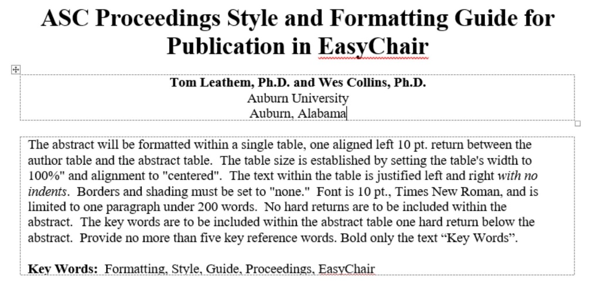
Figure 2a. One or more authors from same institution

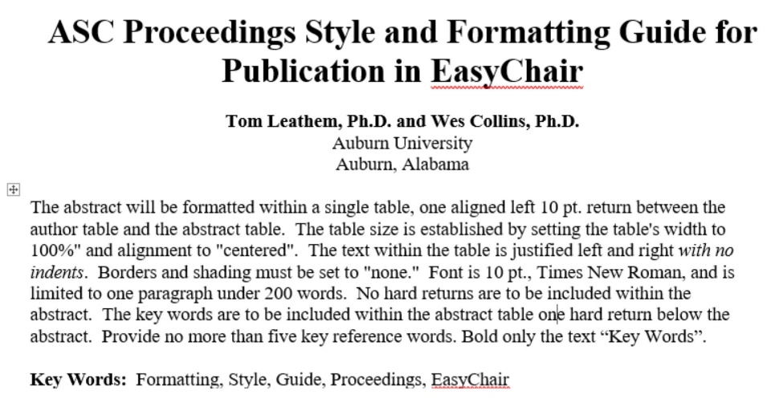
Figure 2b. Table borders hidden to show actual example

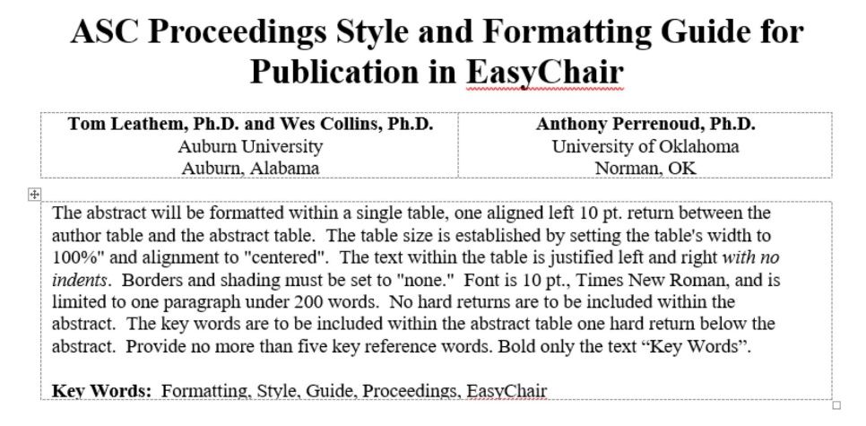
Figure 3. Two authors from different institutions

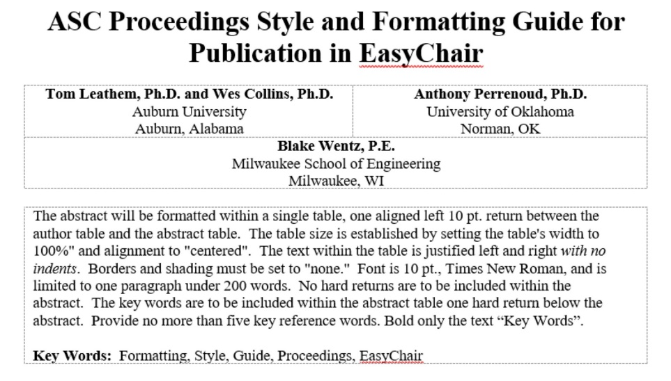
Figure 4. Three or more authors from different institutions

1st Level Headings

Font size is 12 pt., Times New Roman, and bold. Headings are centered, upper and lower case (Title Case). Two (2) hard returns before the heading and one (1) hard return after the heading.

2nd Level Headings

Font size is 12 pt., Times New Roman. Headings are centered, italicized, uppercase and lowercase heading, 1 line space before, and 1 line space after.

3rd Level Headings

Font size is 12 pt., Times New Roman. Headings are flush left, italicized, uppercase and lowercase side heading, 1 line space before, and 1 line space after.

4th level headings. Font size is 12 pt., Times New Roman and are flush left, italicized, lowercase paragraph heading ending with a period (.), 1 line space before, 3 character spaces after, paragraph begins same line.

Citations

Citations are within parenthesis, place (author's surname and publication year) within the text at the appropriate point. All citations must refer to sources listed in the references, and all sources listed must be cited from within the text. Refer to the examples below for proper listing of sources.

Examples:
Paraphrasing:
. . . As written (Jones & Moss, 1997). Or . . . As written (Jones & Moss, 1997) in the . .
Directly quoting:
". . . As written" (Jones & Moss, 1997, p.17). Or . . . "as written" (Jones & Moss, 1997, p.17) in the . . .
Citing figures and tables:
. . . As written (see figure 5).
. . . As written (see table 5) in the . . .

Tables

Textual information presented in column and row format. All tables must be created using the table function within the same word processing system as the manuscript. No table may be included as an image file or inserted as a reference to another file document, i.e. Excel, Access. The table size is established by setting the table's width to 100%" and alignment to "centered". All table elements (including titles) use Times New Roman, 10pt font. Appear at top of table (note punctuation, capitalization, and formatting displayed by the examples) and within its own row cell. Borders and shading must be set to "none” except the title cell, header cells, and the last cell which should have the bottom cell boundary as a 1/2 pt. line. Column headings can be bold. Information within the table is to be formatted Times New Roman 10pt font. There should be a hard return before and after the table. Tables in excess of 40 lines in total will be included as an appendix.

Table 1

Example of table format with borders shown for formatting clarity

SLO | Description of SLO
1 | Create written communications appropriate to the construction discipline
2 | Create oral presentations appropriate to the construction discipline.
3 | Create a construction project safety plan.
4 | Create construction project cost estimates.
20 | Understand the basic principles of mechanical, electrical and piping systems.

Table 1

Example table with borders hidden as final actual

SLO | Description of SLO
1 | Create written communications appropriate to the construction discipline
2 | Create oral presentations appropriate to the construction discipline.
3 | Create a construction project safety plan.
4 | Create construction project cost estimates.
20 | Understand the basic principles of mechanical, electrical and piping systems.

Figures

Figures include non-text entries such as graphs, illustrations, photos, and artwork (tables are not figures). Figures should be drawn using a suitable drawing package and embedded within the manuscript document. Only .gif and .jpg file formats are considered acceptable. Submitted images should adhere to the resolution setting of 300 dpi. A two (2) celled table contains the figures (center justified) and figure title (center justified). Figures will not have borders drawn around them and should be limited to two-thirds (⅔'s) of a page. The table size is established by setting the table's width to 100%" and alignment to "centered". Figure titles use Times New Roman, 10pt font and appear in the bottom cell of the figure table (note punctuation, capitalization and formatting displayed by the examples). Do not include the figure title in the figure itself. The figure below provides an example (note: the table borders are shown only for an example of how the table should be setup).

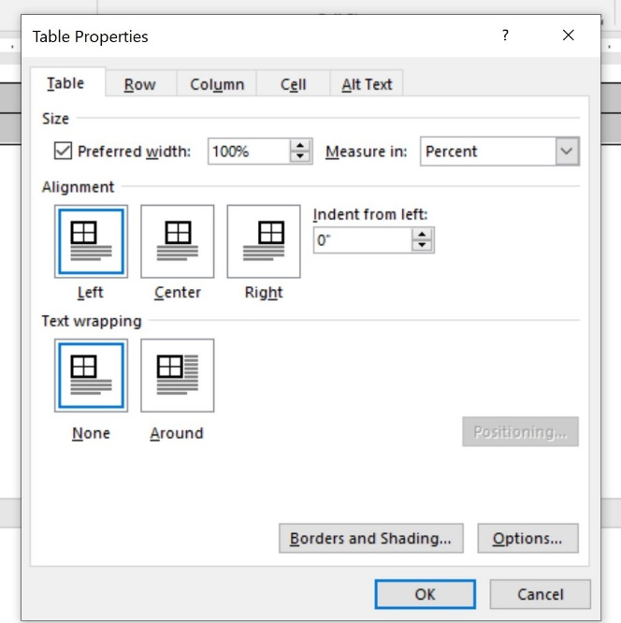
Figure. Example of table properties for figure setup

Bullets and Numbering

Items listed should be syntactically and conceptually parallel to the other items in the list and should be limited to itemized conclusions or steps in a procedure. Only minimal round bullets or Arabic numerals are to be used. The list is one space below the previous paragraph and indented 0.25" and is followed by one left justified space. Each of the separate items in the series is followed by a comma or period. Do not force or hard text your own bullets or numbering using tabs or indents. Use auto formatted only. You may format them to your specific needs. Below is an example of options.

- You may use round bullets
- Or you could use numerals
- In either case the items are indented 0.25" and is followed by one left justified space

References & Appendix

Alphabetical listing of sources that were used in the research and preparation of paper. Manuscripts should conform to the Publication Manual of the American Psychological Association, 6th Edition (2010). References should be indicated in the manuscript by giving the author’s name, with the year of publication in parentheses, e. g. Jones (2004) or (Jones, 2004) as appropriate. If several publications are cited by the same author and from the same year, a, b, c, etc. should be put after the year of publication. Arrange entries in alphabetical order by the surname of the first author. Alphabetize corporate authors, such as associations or government agencies, by the first significant word of the name. Full official names should be used. If there is no author, the title moves to the title position, and the entry is alphabetized by the first significant word of the title. One hard return, aligned left, will provide a space between all entries. Single-space each entry. All references cited in the text should be listed in full at the end of the paper (see examples below).

Appendices are labeled A, B, and C (when there is more than one), and are placed in the order they are first referenced in the text. Please limit number of pages. Information within the appendix is to be formatted font size 10 pt., Times New Roman.

